**Neural Networks & Deep Learning: ICP5**

**NAME: BALA RISHIK MARNENI**

**STUDENT ID: 700746746**

**GITHUB LINK:** [**https://github.com/BalaRishik001/Neural-Networks-and-Deep-Learning-Assignments**](https://github.com/BalaRishik001/Neural-Networks-and-Deep-Learning-Assignments) **VIDEO LINK:** [**https://drive.google.com/file/d/11_f-Foj_SmtvhGaQweNYJvq5C1qsAGVU/view?usp=drive_link**](https://drive.google.com/file/d/11_f-Foj_SmtvhGaQweNYJvq5C1qsAGVU/view?usp=drive_link)

1. Implement Naïve Bayes method using scikit-learn library Use dataset available with name **glass**

Use **train_test_split** to create training and testing part Evaluate the model on **test part** using score and

classification_report(y_true, y_pred)

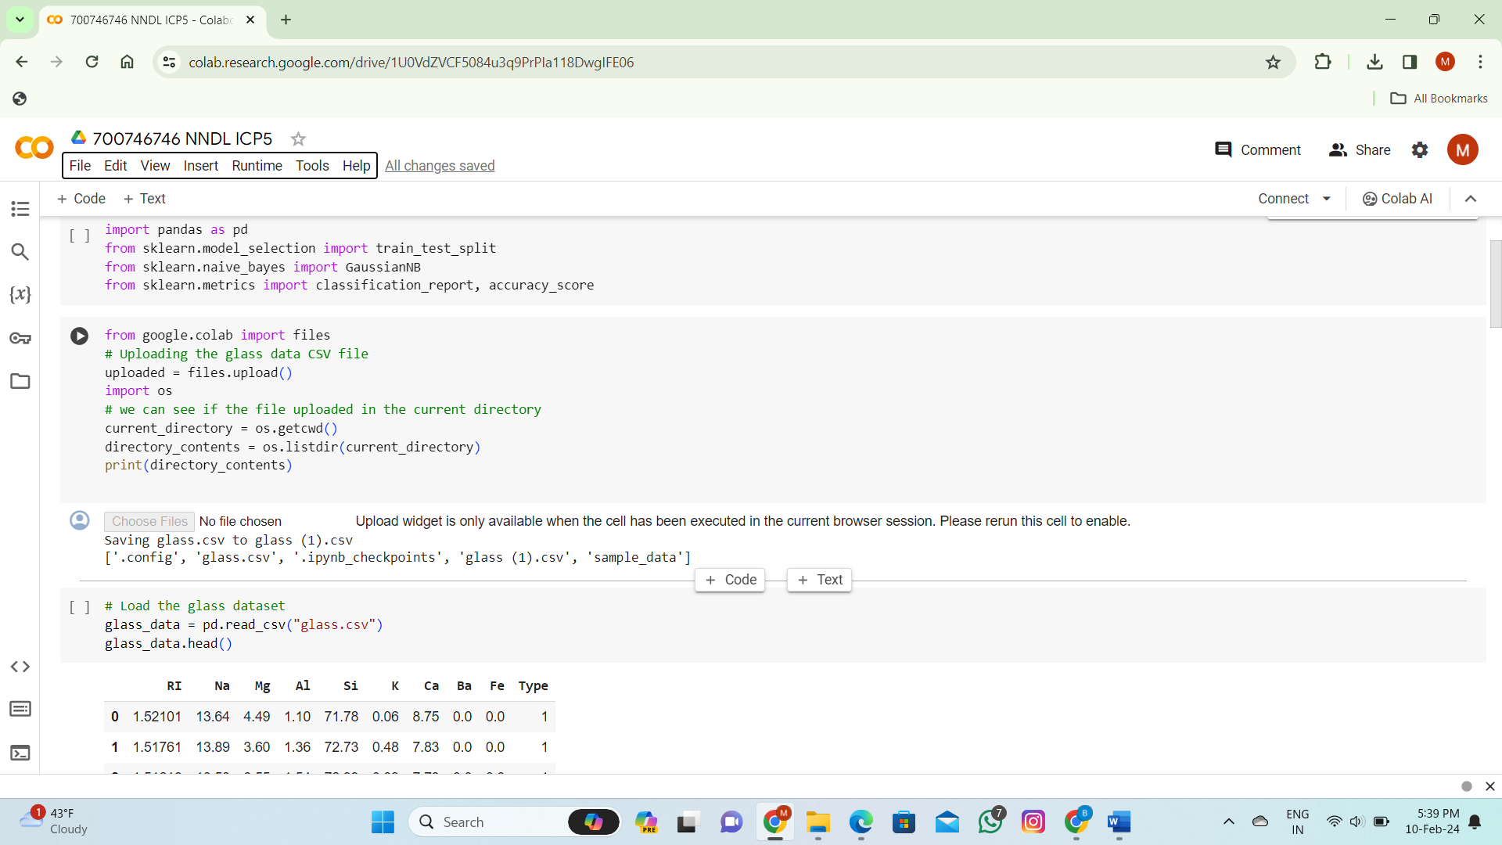

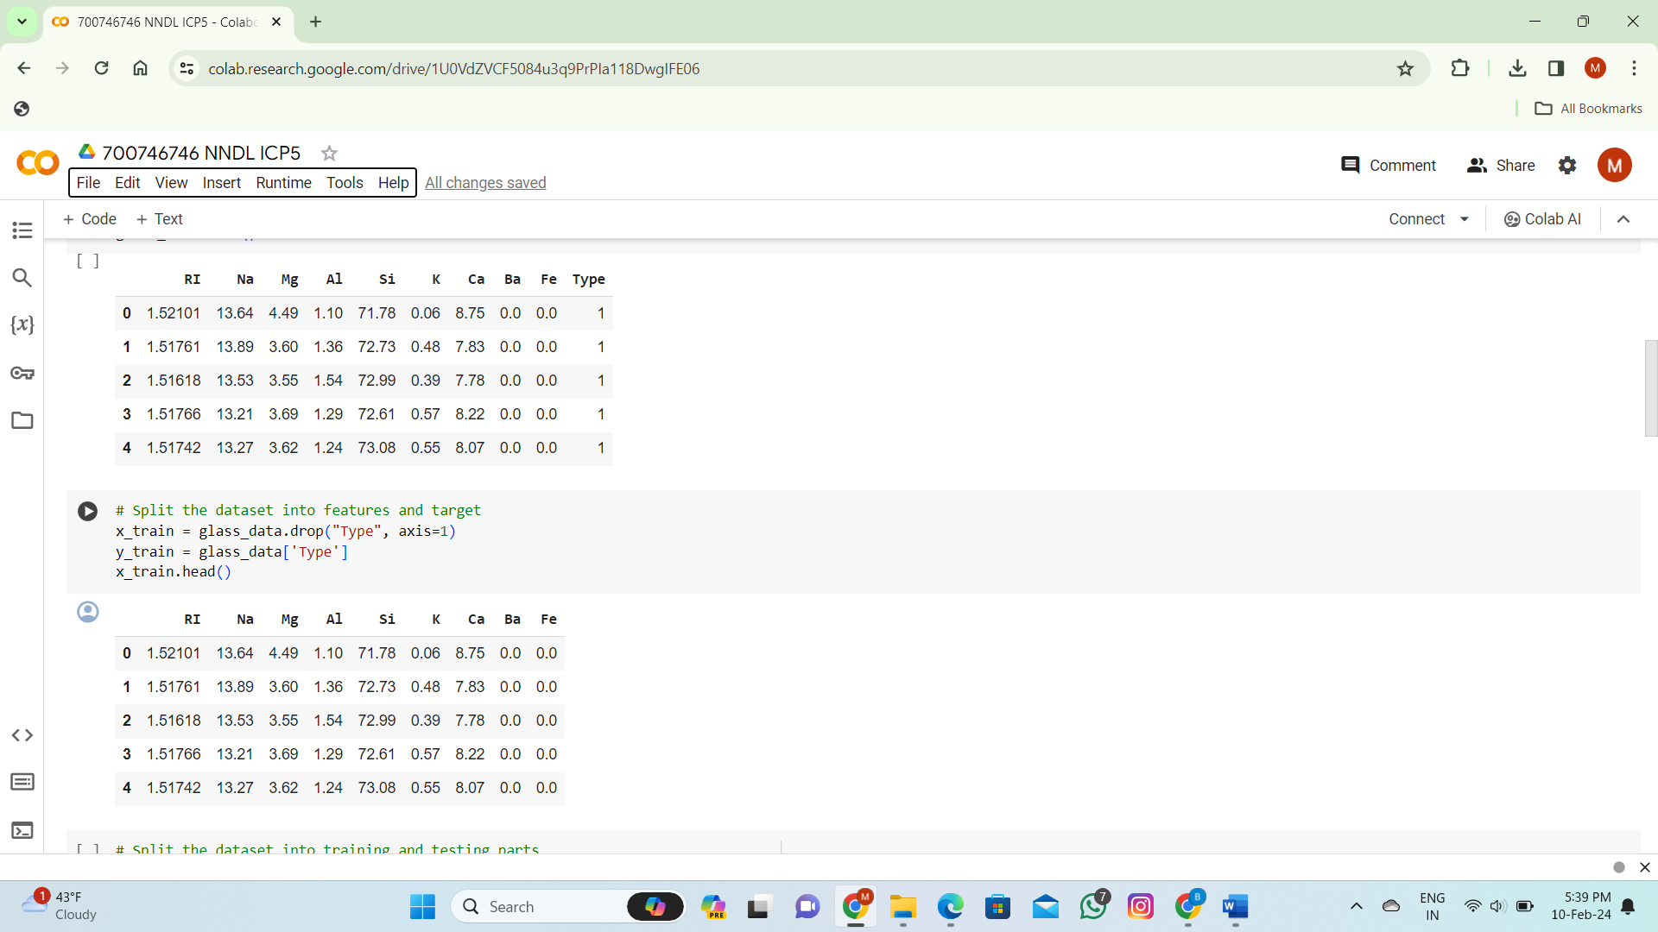

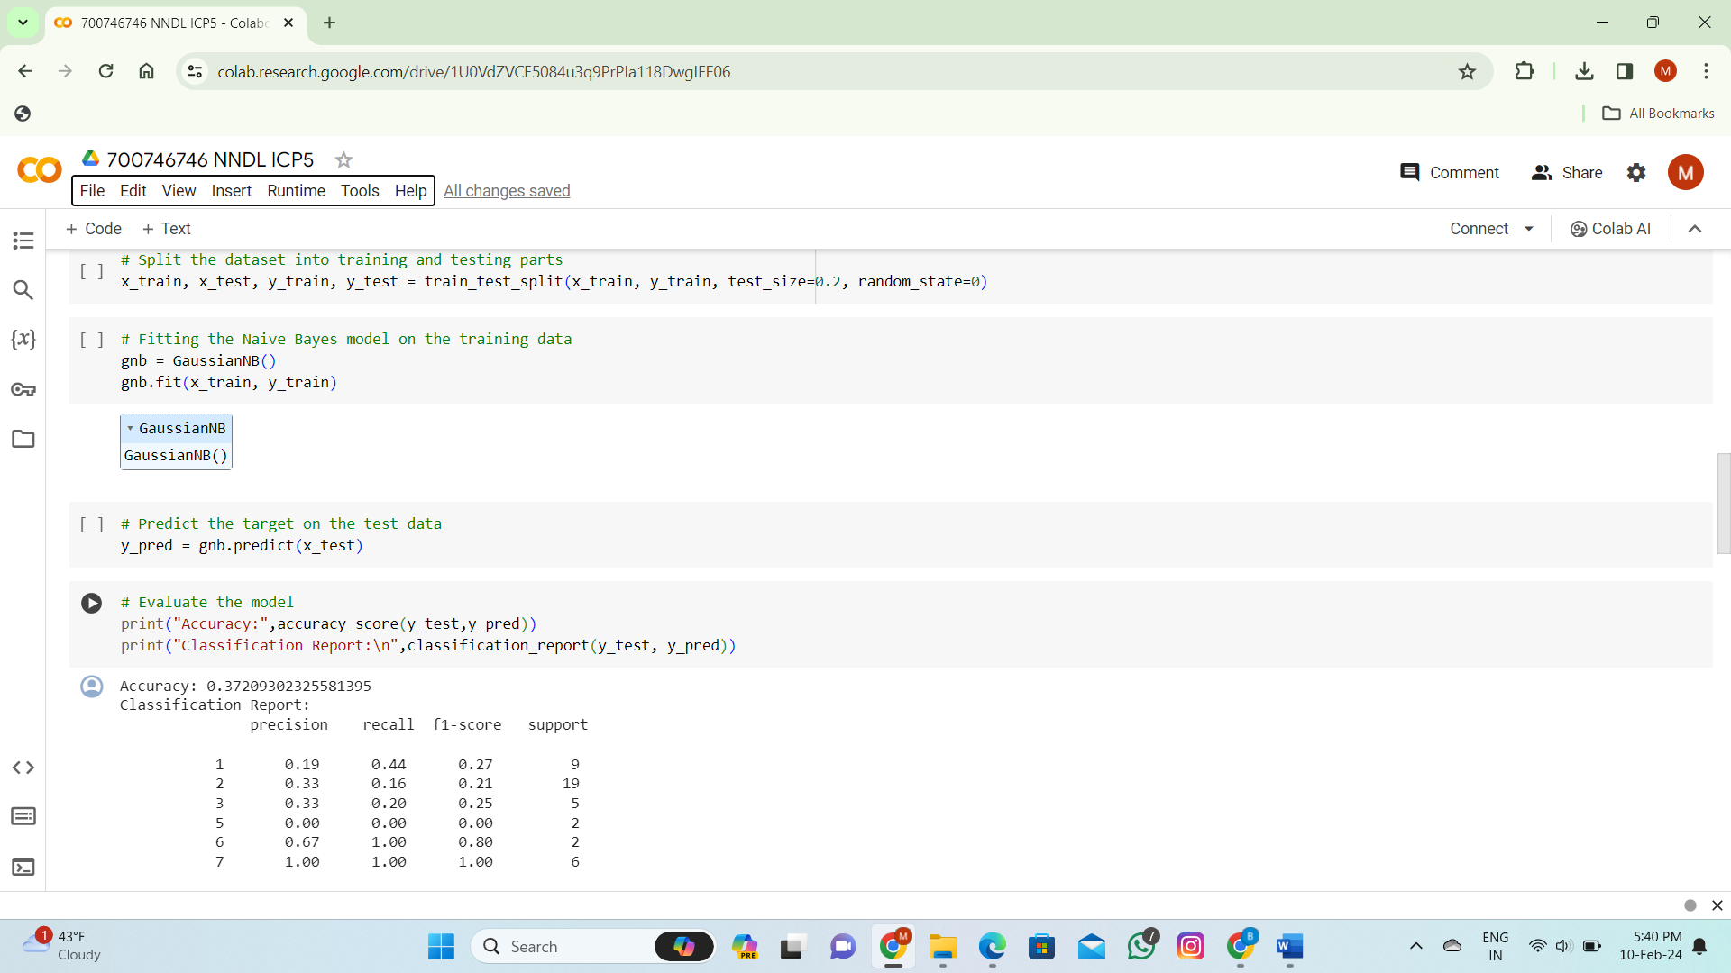

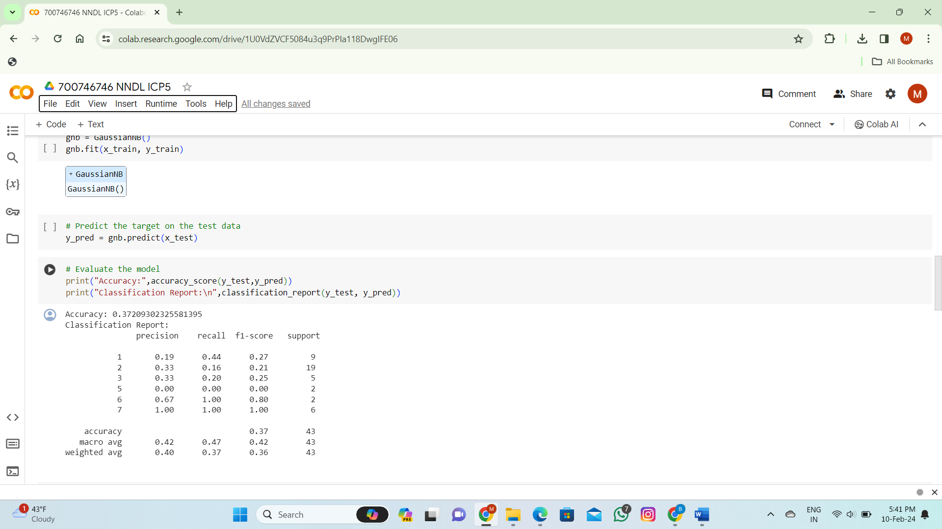

1. Implement linear SVM method using scikit library

Use the same dataset above

Use **train_test_split** to create training and testing part Evaluate the model on **test part** using score and

classification_report(y_true, y_pred)

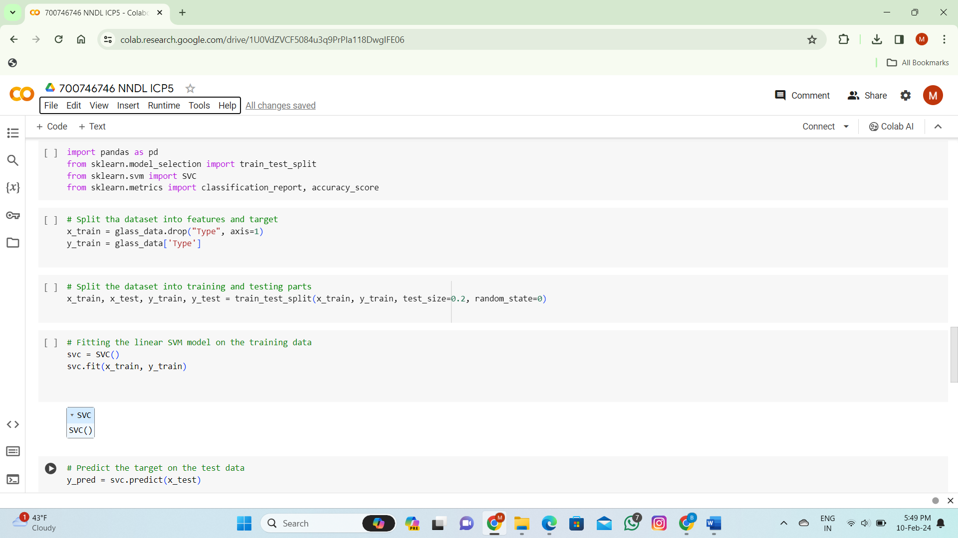

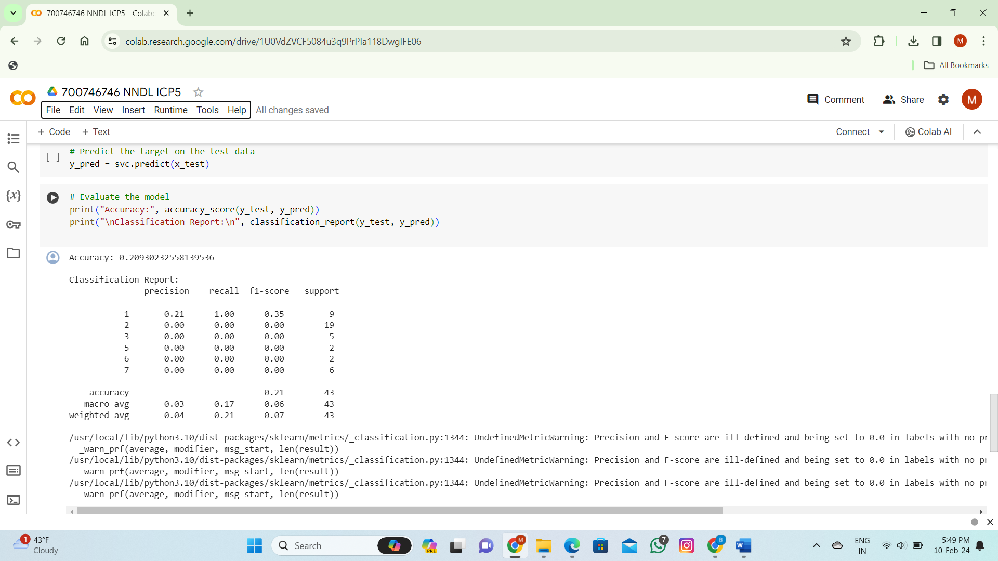

Which algorithm you got better accuracy? Can you justify why?

Ans:We got an accuracy of 0.37209302325581395 using NaïveBayes method and an accuracy of 0.20930232558139536 using linear SVM method. So it is evident that Naive Bayes algorithm produced better accuracy when compared to SVM method because of the maximum correct predictions. Eventhough SVM's work with both linear and non-linear data, but can be particulary useful for non-linear data.  
  
  
  
  
 **THANK YOU**